Path Selection and Movement to the Ongoing Function:

Staff should not move a case to an ongoing function if it is not a true ongoing case. True ongoing cases have identified abuse/neglect/dependency. Assessments identify the safety issues or risk factors that contributed to harm or risk of harm. Case plans are written to reduce identified risks and reduce the likelihood of future harm. In order to ensure accurate caseload agency data, only certain paths should to the ongoing function at the conclusion of the assessment.

The selection of the staff determination at intake determines the path of the assessment.

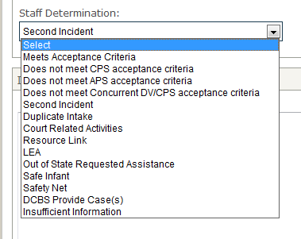
Paths that will permit a decision to open for ongoing services:
- Meets Criteria, Maltreatment Cases
- Meets Criteria, Dependency
- Court Related, Status Offenders
- Safe Infant
- APS Assessments (except Guardianship Assessments)

Paths that will not permit a decision to open for ongoing services:
- Law Enforcement Assist
- Court Ordered Risk Assessments/Evaluations
- Resource Links
- Out of State Requests for Assistance
- APS Guardianship Assessments

Regarding court ordered risk assessments or out of state requests for assistance:
These paths are not intended to be counted as true ongoing protection cases. They are service assignments for which iTWIST provides an open documentation path for as long as necessary to satisfy the court order or monitor service provision on behalf of a child or family. There is no time frame on these documentation paths. These documentation paths will count correctly as a case and an obligation assigned to that worker in management reports.

